**Lung Disease Detection using VGG-19, EfficientNet and Inception V3 hybrid Machine Learning Algorithms**

Dr. K. Reddy Madhavi1, Macha Venkata Sandeep2, Malli Santhi Kumar3,

Paluru Neha4, R Surya Narayana Reddy5

1 School of Computing, Mohan Babu University, Tirupati, India

2Department Of Computer Science and Engineering (CSE), Sree Vidyanikethan Engineering College (Autonomous), India

**Contents**

|  |  |  |
| --- | --- | --- |
| X.1 | Introduction | 2 |
| X.2 | Literature Review | 3 |
| X.2.1 | Relevant work about Methodologies | 6 |
| X.3 | Analysis | 6 |
| X.3.1 | Existing System | 7 |
| X.3.2 | Proposed System | 7 |
| X.4 | Algorithms and Architecture | 9 |
| X.5 | Methodology | 11 |
| X.6 | Datasets and Inputs | 14 |
| X.6.1 | Metrics | 15 |
| X.7 | Results | 16 |
| X.8 | Conclusion and Future Work | 18 |
| X.9 | References | 19 |

# Abstract

Lung disease is common throughout the world. These include chronic obstructive pulmonary disease, pneumonia, asthma, tuberculosis, fibrosis, etc. Pneumonia is common worldwide. These include COPD, pneumonia, asthma, tuberculosis, fibrosis, etc. takes place. Rapid diagnosis of lung disease is very important. Many image processing and machine learning models have been developed for this purpose. Convolutional neural network (CNN), General neural network, Visual geometry group based neural network (VGG), Capsule network etc. Deep learning is used to predict lung disease. Basic CNN does not work well with rotation, tilt, or other unusual image orientations. Therefore, we propose a new hybrid deep learning framework that combines VGG, data augmentation, spatial transformation network (STN), and CNN. This new connection, here called VGG Data STN, tools CNN (VDSNet) using Jupyter Notebook, Tensorflow and Keras. The new model was applied to a database of NIH chest xray images collected from the Kaggle repository.

**Keywords**: pneumonia, CNN, VGG, STN, Tensorflow, Keras, Machinelearning.

**X. 1. Introduction**

The rate at which the globe is changing is so rapid that there is a growing need for health care, unfavorable climate change, rising terrain, and an increase in earthborn life leads to the peril of fondness. This paper will include a section on lung problems. In 2015, smoking and pollution were the main causes of 3.2 million deaths from chronic obstructive pulmonary disease (COPD), while asthma claimed the lives of 1.2 million people.

This is just one instance of a sickness that can be prevented if detected early, given the wide range of alternatives and lung problems that people may experience. Technological machines and computer power can help with preliminary diagnosis of problems, especially lung complications, enabling us to detect ahead of time and more precisely are, after cardiac problems, among the most prevalent complications in India. Pneumonia, tuberculosis, and more COVID-19 effects fall within the group of respiratory illnesses.

The International Respiratory Societies (IRS) reports that over 300 million people globally experience asthma-related problems, and these lung illnesses claim the lives of over 2 million people annually. Current research indicates that millions of people contracted COVID-19, leading to a notable loss of life. These lung conditions are often a major cause of death and a worldwide tragedy. In general, we want to use deep learning to detect patterns in chest X-rays and then construct likely learnt features from those images in the medical industry. Deep learning is increasingly becoming the standard in a wide range of medical applications, assisting medical department personnel and doctors in detecting and classifying minor medical anomalies more quickly and efficiently. Much research has been conducted in order to discover lung diseases. This study discusses the history of deep learning and how it is used in pulmonary imaging applications. Deep learning algorithms are being used to treat a variety of lung illnesses.

The likelihood of recovery increases with early diagnosis and treatment of lung problems, and recovery rates vary depending on these factors. Previously, X-rays, CT scans, skin tests, and blood tests were used to identify lung disorders. The report will be examined by the radiology department, and if the radiologist is not present at all times, a concerned party with adequate knowledge will try to differentiate the report from the test sample. Many addicts are now seeking help from medical professionals in the hopes of identifying and averting anomalies, thanks to recently obtained substantial information. Therefore, using our deep learning method to lung problem auguring, we try to characterize the abnormalities present in the lungs via a chest X-ray examination.

# X. 2. Literature Review

**R. Mahum & A. S. Al-Salman** **et al.,** introduce a new deep learning approach for lung cancer detection that is the Lung RetinaNet. Leveraging the RetinaNet architecture, the model incorporates multi-scale feature fusion and a context module to enable it captures effectively lung nodules suggestive of cancers in medical images. In order to enhance precision, the solution of method shown here has addressed a key requirement for early identification of lung cancer by using sophisticated deep learning methods. Lung-RetinaNet neglects potential crowded objects but proves to be effective in detecting lung nodules of various sizes and complexity by merging features at different scales, as well as providing contextual information.

**Ravi, V., & Alazab M et al.,** propose a new technique for identifying lung diseases from chest X-ray images based on stacking ensemble with the EfficientNet models. This technique is designed to enhance detection accuracy by using complementary features through a process of combining several models trained on distinct image channels. Thus, the creative approach not only contributes to moving on medical image analysis in a positive direction but also presents new opportunities to provide more precise and accurate diagnoses based domedicine chest X-ray images.

**Vasamsetti et al.,** demonstrated several deep learning models based on their ability to predict pulmonary diseases from X-rays of the chest. By applying comparative analysis, the study seeks to define which model is best suited according to aspects such as precision and computational efficiency that are scalable. The contribution made in this research is to provide useful information on the performance of deep learning architectures for diagnosis prediction by addressing the critical need that there are accurate tools within ones health system. Additional confirmation and analysis in relation to up-to date technologies would increase the totality of findings as well as its practical application within a framework of healthcare infrastructure.

**Mujahid et al.,** studies the use of deep learning techniques especially Inception-V3 and convolutional neural networks (CNNs) to classify pneumonia correctly from Xray images. The study achieves these objectives by exploiting advanced neural network architectures thus improving diagnostic sensitivity and specificity in health care systems. This study provides informative knowledge about the efficiency of deep-learning based methods in classification on pneumonia images and can lead to improvements in analysis techniques for medical imaging diagnosis.

**Sharma and Guleria et al.,** describes the introduction of a type of deep learning model that can be used to anticipate early pneumonia in its infancy. Parametrically, the authors strive to improve pneumonia diagnosis accuracy and speed by combining VGG19 architecture with neural networks. This research helps to identify the important aspect of early detection in pneumonia as this is very vital for any timely medical intervention and success outcome. Through the application of state-of-the art deep learning algorithms, our suggested model is a valuable addition to heterogeneous literature on AIDTs in medicine. Further study and comparison of the approach with other methodologies would help to judge its effectiveness and general applicability.

**Choudhary P. and A. Hazra et al.,** discuss the use of CNNs for chest disease detection in radiography images with transfer learning. Through deep learning methods, especially by using CNNs and transferring the type of information to other larger networks, they plan on making their diagnostic process for chest diseases from radiography images more precise and faster. The focus of this study is to solve the critical problem in healthcare that lacks automated diagnostic tools by analyzing sophisticated machine learning techniques for chest disease detection. The study provides further evidence concerning the development of deep learning-based medical image analysis methods, bringing attention to CNN and transfer learning effectiveness in chest disease diagnosis. In addition, further validation and comparison with other methodologies would increase the generality of the findings, their practicality for clinical practice.

**Bharati S. et al.** study different classification techniques to predict lung cancer. By comparing the performance metrics of various algorithms, this research attempts to determine which algorithm is most suitable for accomplishing this task. The investigation brings significant findings in regard to the effectiveness of various machine learning algorithms that target one crucial need for healthcare, which is accurate predictive models specifically aimed at effectively diagnosing lung cancer. This comparative analysis serves as a basis for choosing the best performing algorithms, which can ultimately increase diagnostic accuracy and enhance patient outcomes. Additional investigation of other algorithms would improve the scope of conclusions and their clinical utility.

**Bhandary Abhir et al.,** proposes a deep learning method for detecting lung abnormalities from chest X-ray and CT scan images This work helps to address the necessity of precise and effective diagnostic tools in medicine based on state-of-the-art deep learning technologies. Using a deep learning framework, the authors want to promote speed and accuracy of lung abnormality diagnosis resulting in early identification in successful treatment. The study offers important information about the use of deep learning in medical image analysis, especially regarding lung health. Introduction of further validation and comparison with existing methodologies would improve the completeness of results as well as their potential application in clinical practice.

**Rahaman et al.,** studies the application of deep learning methods to detect COVID-19 cases from chest X-rays images. The research compares several transfer learning techniques to find the approach that will yield accurate results in detecting COVID from X-ray images. The findings of this study are especially timely during the COVID-19 pandemic, which highlights the need for reliable and effective diagnostic instruments. Thus, examining deep learning in medical imaging analysis is crucial given its significant contributions toward fulfillment of such prescient demands This paper adds to the growing body of literature on automatic COVID-19 diagnosis and provides possible improvements in early detection and treatment. IoT System does not conduct further validation or comparison with other methodologies , which could improve the generalizability of its findings and their clinical relevance.

|  |  |  |  |
| --- | --- | --- | --- |
| Author | Methods | Performance | Database |
| Bharati S Podder P Mondal R Mahmood Raihan-Al-Masud M | Naïve Bayes, Logistic Regression, K- Nearest Neighbors (KNN),Tree,  Random Forest,  And Neural Network classification | 57.047% | UCI machine learning repository |
| M. Rahaman  Kulwa F Wang Q | CNN | 89.3% | LUNA16 |
| Bhandary Abhir | MAN+SVM | 97.27% | Kaggle repository |
| P. Choudhary | CNN+VGG16 | 83.671% | LUNA16 |
| Mujahid M | CNN+Inception V3 | 99.29% | Kaggle repository |
| R. Mahum  A. S. Al-Salman | ResNet | 99.8% | Simba Lung Database |
| S. Sharma  K. Guleria | VGG19 | 93% | Kaggle Repository |
| Song Q, Zhao L, Luo X, Dou X | CNN+DNN+SAE | 84.15% | LIDC-IDRI |
| Masud MRA, Mondal MRH | SVM+LR | 86.96% | Kaggle Repository |
| Ahsan M.M Alam T.E Alam T.E | Adam+Sgd+ Rmsprop | 94.6% | Kaggle repository |

# X. 2.1. Relevant work about Methodologies

The architectures EfficientNet, Inception V3, and VGG-19 are very much useful in examining medical images, particularly chest X-rays, to detect lung diseases such as pneumonia, TB, cancer, and COVID-19. The notable benefit of these architectures is diagnosis automation, which reduces the pressure on radiologists. Improvising of Accuracy can be achieved, and it helps in disease identification, potentially saving many lives. To gain maximum performance and efficiency, EfficientNet combines depth,width and resolution. The architectures EfficientNet, Inception V3, and VGG-19 are very much useful in examining medical images, particularly chest X-rays, to detect lung diseases such as pneumonia, TB, cancer, and COVID-19. The notable benefit of these architectures is diagnosis automation, which reduces the pressure on radiologists.

Improvising of Accuracy can be achieved, and it helps in disease identification, potentially saving many lives. To gain maximum performance and efficiency, EfficientNet combines depth,width and resolution. It achieves great accuracy in lung disease detection by using fewer parameters. Inception V3 supports several kernel sizes in order to capture features at different scales inside modules. For efficiency, this Architecture maintains a balance of computational costs. VGG 19 goes deeper into the dataset by capturing complicated features with 19 layers. Convolutional Small Filters with pooling, such as 3x3 filters, are useful for learning difficult patterns.

|  |  |  |  |
| --- | --- | --- | --- |
| Architecture | Accuracy | Parameters | Training Time |
| EfficientNet-B7 | 94.6% | 5.3M | Medium |
| Inception V3 | 94.1% | 23.8M | Longer |
| VGG-19 | 92.8% | 143.6M | Slower |

In summary, the relevant work in brain tumor analysis spans classical machine learning methods, deep learning architectures for classification and segmentation, and the exploration of multi-modal data fusion. Our integrated system builds upon these foundations, offering a cohesive framework that not only leverages the strengths of individual methodologies but also addresses the existing gap in unifying classification and segmentation for a more nuanced and informed diagnostic process.

# X. 3. Analysis

The core objective of our lung disease analysis system is to provide an accessible and user-friendly platform for effective medical diagnosis. The key goals of this project include:

* Experimenting with different architectures and hyperparameters.
* Address class imbalance if necessary.
* Consider interpretability techniques for model understanding.

Based on current technological conditions, it is anticipated that this important data set will aid the community in studying and constructing a model. The data collection includes age, gender, patient data, snapshot data, and other pertinent information. X-ray images These main data are used to model it.

**X. 3.1. Existing System**

The current system has no idea how to use CNN models to detect lung cancer. All forecasts were created from scratch or with the use of simple Machine Learning algorithms. Although machine learning can determine whether or not lung cancer has been discovered, these models cannot accurately and consistently classify records.

**X. 3.2. Proposed System**

The elementary initiation of the proposed project is to create an application that uses chest X-ray pictures to analyse and detect lung cancer. Chest X-ray photos with cancer symptoms from the KAGGLE are collected in this study to train the developed algorithm. Once the system is trained, the productivity of the model can be evaluated by providing extreme results and evaluating the efficiency of each unique model. Deep Learning could be handy for people living longer lives by predicting lung disease using chest X-rays.

By using these methods, the outcomes can be precisely predicted in real-time. In this methodology, to provide an excellent technique for expert identification of lung illnesses, hybrid deep learning models are employed. The CNN model under consideration for diagnosing chest illness uses pre-trained CNN models such as VGG19. The application is divided into four pieces. Here are the details:

1. Convolution Layer

2. Pooling Layer

3. Rectified Linear Unit (RELU)

4. Fully connected layer.

1. **Convolution Layer :**

Convolution is a process with two functions. Both involve a set of numbers, with the first including adjacent pixels at a given position in the image and the second involving a filter (or kernel). The result is obtained by taking the dot average of the two functions. The filter is then shifted to the next photo location, which is determined by the stride length. A feature (or activation) map is created by repeating the technique until the whole frame has been covered. The filter is active in this diagram, and it "sees" objects like a linear manner, a dot, or a crooked edge. When a CNN gets a facial image, the filters attempt to detect low-level details such as lines and edges. In successive levels of the CNN architecture, the component mappings build up to ever greater features, such as a nose, eye, or ear, as inputs for the next level.

1. **RELU (Rectified Linear Unit Layer) :**

Negative input values are converted to zero using the RELU function. This helps to avoid the degradation problem by reducing and speeding up calculations and training. f(x) =max is the mathematical formula (0, x). The neuron receives x as an input. Sigmoid, tanh, faulty RELUs, Completely random RELUs, and dynamic RELUs are some of the other activation functions.

1. **Pooling Layer :**

The Pooling layer in between the convolutional layers helps to reduce dimensionality for evaluation and image size as well. There are two other common types of max pooling known as the Pooled and L2-normalization pooling. Maximum pooling accumulates the highest activations over a neighbourhood by choosing that input value as having the maximum activation, which is located within such a filter and then discarding all other values. The underlying idea is that how much the feature of extremely high activity interacts with its neighbour emphasizes on what position at which proximity it creates.

1. **Fully Connected Layer :**

In the above network, each layer across all layers of previous layer is connected to every neuron in CNN’s Fully Connected Layer. Based on the required complexity of component abstraction, there can be one or more fully connected layers that are analogous to inversion, RELU and pooling. Output from the previous layer is used by this layer in determining classification probability values into different categories (Convolution, RELU or Pooling). This layer evaluates the top dynamic properties of an image and determines whether it can fit into a particular category. For instance, histopathology glass slides show that cancer cells have a high DNA to cytoplasmic ratio compared with normal cells.

**X. 3.3. Data Exploration :**

Chest X-rays are one of the most common and affordable medical imaging treatments. NIH Chest X-Ray Dataset (National Institutes of Health Chest X-Ray Dataset). A chest X-ray, on the other hand, may be more difficult to diagnose clinically than a chest CT scan. Due to a scarcity of big publically available datasets with annotations, clinically relevant computer-aided diagnosis (CAD) in real-world medical settings employing chest X-rays remains difficult, if not impossible. One of the most difficult parts of producing big X-ray image sets is the lack of finances for categorizing so many photographs. Prior to the introduction of this collection, Opening had the largest publicly available collection of chest X-ray images, with 4,143 images. The X-ray picture collection from the National Institutes of Health has 112,120 pictures and medical explanations for 30,805 patients. Each patient got a special reason to be there before getting their x-ray done. The authors made these labels using Natural Language Processing. They looked at disease tags from connected medical imagery data in the text. Labels must be more than 90% correct and easily understood without watching. Although actual radiology findings are not widely available, "ChestX-ray8”: The open access paper, "Hospital-scale Chest X-ray Database and Marks for Small teaching on Identifying and Cutting out Common Lung Illnesses," offers more details about the labeling process. (Wang and team) Some of the photos show strange situations like hernia, pneumonia and hard tissue build-up. They also display common lung problems such as fluid in lungs or parts filled with air not working well again we will trust them by saying there's (a lack that fail correctness). Disease distribution is undeniably unequal. The list has more guys than girls and the number of sure cases is bigger than the confirmed men with lung problems. If the situation isn't planned, then things will be different in a less big way. Diagram of patient distribution by gender:

View Position:

**Posterior-anterior (PA) Position:**

An x-ray of an adult's chest should be taken in the back to front position. This is called posterior-anterior (PA). The person who is sick stands tall and pushes their chest against the picture's front side. The arms are pushed forward to touch the film, making sure no lung areas are hidden by shoulder bones. Normally given when the patient is fully awake. Pretend the patient is in front of you as you look at the PA video.

**Anterior-posterior (AP) Position:**

When the person is in hospital, can't move or cooperate with PA process they use this method. When the person lies down, the movie is put behind his or her back. Since the heart is further away from the film, it looks bigger than in a PA. Also because scapulas aren't hidden as they are in a PA, you can see them clearly within lung fields now.

**X. 4. Algorithms and Architecture :  
1. Algorithm:**

With new datasets which have never been fully modelled: This is a tough computer image data handling language. This is the ideal technique to utilize given the enormous amount of data in the entire dataset; nonetheless, some parameters must be reviewed and used:

• Pick the best plan for your brain network.

• Parameters for pre-processing

• Optimization

• Transformer of space

• Parameters for training

• Photos and extra information should be put on the internet.

**2. Architecture:**

* Optimal system with VGG-19 pre-trained model as well as Spatial Transformer and additional data.
* Three primary strata are involved in making of architecuture, which are regarded as follows:
* Layers of spatial transformers.
* The important and primary strata is lambda, which helps in transferring of routing features [-0.5:0.5], implying that the image’s characteristics have an average value of 0.”lambda x:2*x-1” is the lambda function.
* Second option is Batch Normalization.
* The Spatial Transformer is the third layer, which uses the net localization of a small CNN to retrieve the most critical information for classification.
* After the three Convolution layers, Maxpooling is applied with a doubling depth of 16-32-64 and a kernel size of 7 5-3, padding = ‘valid’.
* First straighten the layer and then add three dense layers of decreasing depth, activation=’relu’ Extract features layers (VGG19 pre-trained model).
* Set of 13 layers are required to extract features, as indicated in the VGG sketch. There are various pre-trained models, but I’m starting with VGG19 because it’s a simple model that takes less time to learn and train.

**Classification Layers (Last 3 layers) :**

* The starting layer is considered as a straightened layer made up of output of layers VGG19 and 5 plus “Gender Male, Gender Female, Age, View position AP, and View position PA”.
* These additional features have been introduced to this layer since they will change sorting, as we’ve seen.
* Next is the dropout layer.
* Next to each layer, the coming two levels are Dense with decreasing depth, the dropout is 0.2.

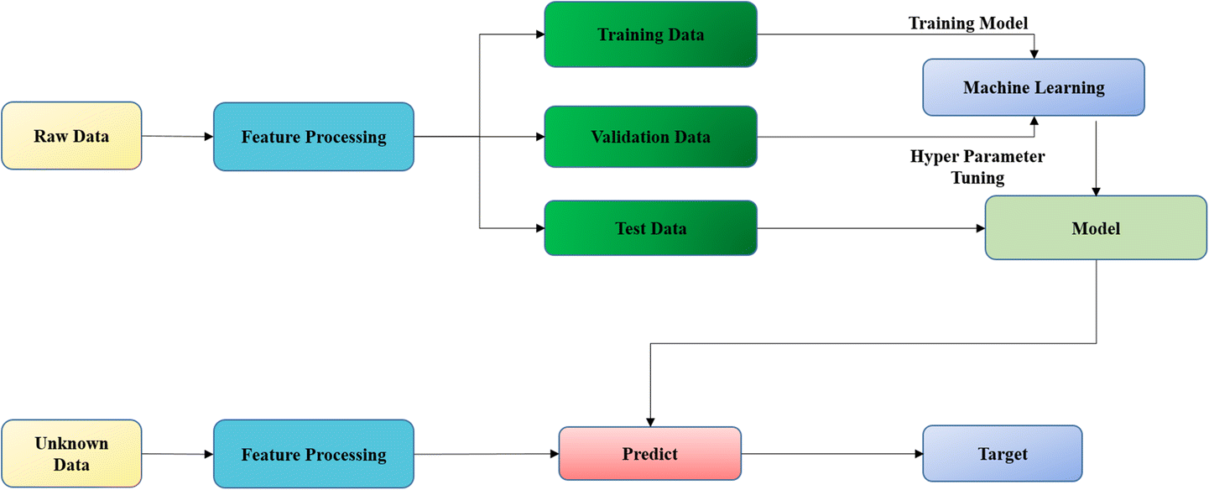

Fig.  [Machine learning and deep learning approach for medical image analysis: diagnosis to detection](https://link.springer.com/article/10.1007/s11042-022-14305-w)

**X. 5. Methodology :**

**Data Collection and Preprocessing:**

Gather a sizable dataset of lung images from various sources, including X-rays, CT scans, or other medical imaging modalities.Annotate the images with labels indicating the presence or absence of lung diseases.Preprocess the images by resizing them to a consistent resolution, normalizing pixel values, and applying any necessary augmentation techniques such as rotation, flipping, or scaling to increase the diversity of the dataset.

**Data Splitting:**

Divide the dataset into training, validation, and test sets. Typically, the training set should contain the majority of the data (e.g., 70-80%), while the validation and test sets should contain the remainder.

Model Architecture Design:

Design a CNN architecture suitable for lung disease detection. This architecture may include convolutional layers, pooling layers, and fully connected layers.Consider using pre-trained models such as VGG, ResNet, or DenseNet as a starting point and fine-tune them for the specific task of lung disease detection.

**Model Training:**

Initialize the CNN model with random weights or pre-trained weights.Train the model using the training data and validate it using the validation set.Utilize techniques like transfer learning, where the model is initialized with weights learned from a different but related task, and fine-tuned on the lung disease dataset to speed up convergence and improve performance.

**Hyperparameter Tuning:**

Experiment with different hyperparameters such as learning rate, batch size, and optimizer (e.g., Adam, SGD) to optimize the model's performance.Use techniques like grid search or random search to systematically explore the hyperparameter space.

Evaluation:

Evaluate the trained model using the test set to assess its performance on unseen data.Calculate metrics such as accuracy, precision, recall, F1-score, and area under the ROC curve (AUC) to measure the model's effectiveness in detecting lung diseases.Analyze the confusion matrix to understand the model's performance across different disease categories.

**Model Interpretation and Visualization:**

Visualize learned features and activation maps to gain insights into what the model is focusing on during classification.Interpret model predictions and identify cases where the model might be making errors.

**Deployment:**

Once satisfied with the model's performance, deploy it in a clinical setting or integrate it into a healthcare system for automated lung disease detection.Ensure that the deployment adheres to regulatory standards for medical devices and consider factors such as real-time processing and scalability.

**Monitoring and Maintenance:**

Monitor the deployed model's performance over time and collect feedback from healthcare professionals.Periodically retrain the model with new data to adapt to changes in disease patterns or imaging technology.Continuously update the model architecture and training pipeline based on advancements in deep learning research.

**X. 6. Datasets and Inputs :**

The project makes use of a Kaggle dataset called sample.zip: sample labels.csv: There are 5,606 images with a resolution of 1024 × 1024 in this collection. There are 15 classes in the whole dataset (14 disorders and one for "No results"), however because this is a much reduced version of the entire dataset, several of the classes are sparse, with the "No findings" labeled:

1. Hernia - 13 images,

2. Pneumonia - 62 images,

3. Fibrosis – 84 images,

4. Edema - 118 images,

5. Emphysema - 127 images,

6. Cardiomegaly - 141 images,

7. Pleural_Thickening - 176 images,

8. Consolidation - 226 images,

9. Pneumothorax - 271 images,

10. Mass - 284 images,

11. Nodule - 313 images,

12. Atelectasis - 508 images,

13. Effusion - 644 images,

14. Infiltration - 967 images, 3044 pictures were not found.

**Inputs :**

Using now popular technology, it is thought that this big set of data will help the community to study and build a plan. This group is made up of age, gender information from patients and other important data about X-ray pictures. This Examine a simple classifier that just guesses the type; it will get 80% right when there's only half and half chances. But, with equal chance of both options, its correctness drops to 50%. These steps will be checked on different data than before. These markers will check if diseases are present. If the outcome is favorable, the following signs apply:

TP: True Positive - Many people are thought to be affected.

FP: False Positive - The guess of how many sick people might not be correct.

FN: False Negative - It is thought that healthy people are misjudged. Precision and Recall will mainy focus on the percentage of people expected to be affected, thereby overcoming the skew data status and the importance of predicting a person's illness.

Recall = TP/ (TP + FN )

Precision = TP / (TP + FP)

Fβ = (1 + β2)* (Recall *Precision)/ β2 ⋅ Precision +Recall

EfficientNet B7 is considered more accurate and efficient than EfficientNet B0, with Accuracy percentages of 94.5% and 85.73% in detecting lung diseases efficiently. This suggests that datasets are likely to perform better when using EfficientNet B7 which when combined with both VGG19 and Inception V3. Accuracy means the number of people who guessed right about getting sick divided by those estimated to fall ill. Recall means how many people correctly predicted getting sick according to the total number of infected individuals. These two signs are really important to know if we will be sick. We need a number that is very exact and correct. We may calculate a F-score by combining Precision and Recall: Difference will show how important and accurate the precision different is. There are two major theories for determining the value of precision and recall:

• Models must be positive that a patient is anticipating a disease, which means that each prediction must be quite sure, because a disease diagnosis is alarming.

• It's critical because doctors can utilize this software to help them with other medical testing. We want a F beta score of = 0.5, which implies high precision but low recall.

• To avoid disease and missing patients at danger, models must avoid mispronouncing sick persons.

In this case, with F beta score = 2, low precision and high recall, equivalent to big, will be picked. Because diagnosing the sickness will necessitate numerous tests on the patient, the goal of the research is to demonstrate the technology while also assisting doctors in treating the disease.

Because the patient will be concerned until the results are known, F-0.5-score = 0.5 was chosen. In this instance, precision will be more important than recall, with 0.5 signifying precision.

**X. 6.1. Metrics :**

Precision, recall, and F-beta scores (beta = 0.5) for binary classification – evaluates the influenzas or not will be utilised as evaluation measures. Because the classes are uneven when using binary classification, F score is greater than accuracy in this scenario. Consider a straightforward classifier that just predicts the classification results it will achieve 80 percent accuracy when the split is 80/20 and 50 percent accuracy when the split is 50/50. These indices will be tested on a dataset that is not the same as the original. Whether or not diseases are discovered, these signs will be evaluated.

If the resulted case is positive, the following indicators apply:

TP: True Positive - The number of people affected is expected to be affected

FP: False Positive - The number of people who are sick is predicted to be unwell

FN: False Negative - The number of people without the disease is predicted to be wrong Precision and Recall will focus on the number of people expected to be affected, thereby overcoming the skew data status and the importance of predicting a person's illness.

The percentage of people who accurately anticipated illness out of the quantity of individuals who were predicted to become ill is known as precision.

On the total number of people infected, recall represents the proportion of people who correctly predicted sickness. Both of these signs are critical in predicting sickness, and we require an index that can be both precise and accurate.

From here, we have a F score that is a combination of Precision and Recall:

Difference will demonstrate the significance of different and precision different.

For choosing the importance of precision and recall, there are two primary ideas:

• Models must be positive that a patient is anticipating a disease, which means that each prediction must be quite sure, because a disease diagnosis is alarming.

• It's critical because doctors can utilise this software to help them with other medical testing. We want a F beta score of = 0.5, which implies high precision but low recall.

• To avoid disease and missing patients at danger, models must avoid mispronouncing sick persons. In this situation, low precision and strong recall, equivalent to large, will be chosen, with F beta score = 2. Because determining the ailment will require several tests on the patient, the goal of this project is to demonstrate the technology as well as assist doctors in diagnosing the disease. Because the patient will be worried until the results are known, I chose F-0.5-score = 0.5. Precision will be more significant than recall in this scenario, with 0.5 representing precision.

**X. 7. Results**

20 random samples were considered and converted into csv format as specified below:

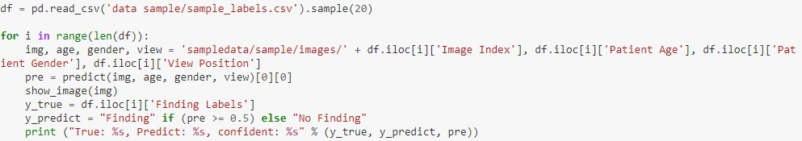

Sample Input1:

**Fig.** Input of disease for checking accuracy

**Output:** Binary accuracy: 0.5701 - precision: 0.5000 - recall: 0.8166(32, 64, 64, 3)

Sample Input2:

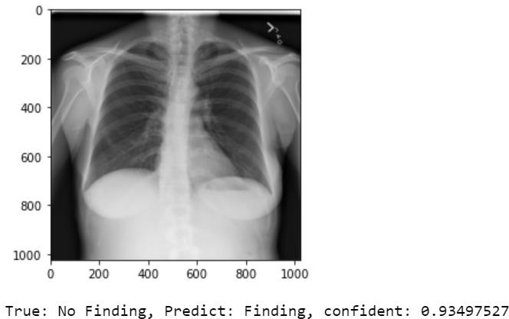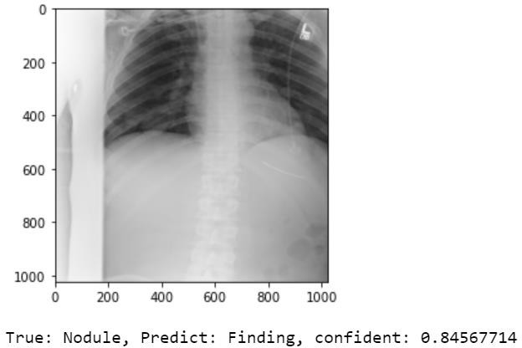

**Fig.** Input of disease for checking accuracy

**Output:** Binary accuracy: 0.5698 - precision: 0.5031 - recall: 0.8281(32, 64, 64, 3)

Sample Input3:

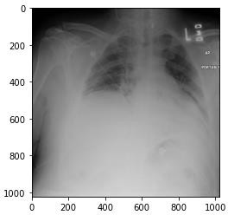

**Fig.** Input of disease for checking accuracy

**Output:** True: No Finding, Predict: Finding, confident: 0.94168824,binary accuracy : 0.5699 - precision: 0.5025 - recall: 0.8263(32, 64, 64, 3)

|  |  |  |  |  |  |  |  |
| --- | --- | --- | --- | --- | --- | --- | --- |
| Proposed System | | | | Existing System | | | |
| Sample Dataset | Precision | Recall | Accuracy | Sample Dataset | Precision | Recall | Accuracy |
| Sample-1 | 0.50 | 0.82 | 56.9% | Sample-1 | 0.58 | 0.50 | 50.7% |
| Sample-2 | 0.72 | 0.45 | 58% | Sample-2 | 0.62 | 0.59 | 51.8% |
| Sample-3 | 0.71 | 0.62 | 76% | Sample-3 | 0.65 | 0.56 | 68% |

**Table**:Performance Comparison between Proposed and Existing System

**X. 8. Conclusion and Future Work:**

A deep learning CNN model is used and developed to diagnose chest or lung problems using chest X-ray photos. An application that can detect and locate problems in the human lungs or chest based on the image's impacted region is developed. The deep complex neural network (Optimized CNN), the most recent image recognition approach, is presently quite exciting to create. A big number of diseased and healthy lung images are collected, the collected samples are used to train the system. The model with a typical chest X-ray image as an input is sent after it has been trained to determine if it has any irregularities. To this problem, we developed a deep learning model that detects anomalies in the human chest using the CNN approach. The proposed system can be used to analyse the lung status of covid patients reducing the amount of physical examinations required during pandemic situation.

**Future Work :**

The findings are based on a small sample size of data, which will be expanded when more data becomes available for future research. The models can then be tailored to a given country to provide even more information. The models were trained over a period of 20 epochs, which can be expanded on computers with better computing power. Various deep learning approaches and models could also be used to compare findings in multimedia medical picture screening. The models chosen and used in this work can serve as a foundation for future research in this field.

**X.9. References :**

1. R. Mahum and A. S. Al-Salman, "Lung-RetinaNet: Lung Cancer Detection Using a RetinaNet With Multi-Scale Feature Fusion and Context Module," in IEEE Access, vol. 11, pp. 53850-53861, 2023, doi: 10.1109/ACCESS.2023.3281259.

[2] Ravi, V., Acharya, V. & Alazab, M. A multichannel EfficientNet deep learning-based stacking ensemble approach for lung disease detection using chest X-ray images. Cluster Comput 26, 1181–1203 (2023). https://doi.org/10.1007/s10586-022-03664-6

[3] S. Vasamsetti, V. Chemboli, G. S. S. Shreyas and S. Thota, "Comparative Performance Analysis of Deep Learning Models for Lung Disease Prediction Using Chest X-Ray Images," 2023 International Conference on Inventive Computation Technologies (ICICT), Lalitpur, Nepal, 2023, pp. 159-165, doi: 10.1109/ICICT57646.2023.10134132.

[4]M. Mujahid, F. Rustam, R. Álvarez, J. L. V.Mazón, I. D. L. T. Díez, and I. Ashraf, “Pneumonia Classification from X-ray Images with Inception-V3 and Convolutional Neural Network”, Diagnostics, Vol. 12, No. 5, pp. 1–16, 2022.

[5] Kholiavchenko M, et al. Contour-aware multi-label chest X-ray organ segmentation. International Journal of Computer Assisted Radiology and Surgery 2020.

[6]Masud MRA, Mondal MRH. Data-driven diagnosis of spinal abnormalities using feature selection and machine learning algorithms. PloS One Feb 2020;15(2): e0228422..

[7] Tang Y, Tang Y, Peng Y, et al. Automated abnormality classification of chest radiographs using deep convolutional neural networks. npj Digit. Med. 2020; 3:70.

[8]Bhandary Abhir, et al. Deep-learning framework to detect lung abnormality – a study with chest X-Ray and lung CT scan images. Pattern Recogn Lett January 2020;129:271–8.

[9] Choudhary P, Hazra A. Chest disease radiography in two-fold: using convolutional neural networks and transfer learning. Evolving Systems 2019; 2019.

[10] T Karnkawinpong1 and Y Limpiyakorn2-Classification of pulmonary tuberculosis lesion with convolutional neural networks-2019.

[11] C. Wang et al., "Pulmonary Image Classification Based on Inception-v3 Transfer Learning Model," in IEEE Access, vol. 7, pp.146533-146541,2019, doi: 10.1109/ACCESS.2019.2946000.

[12] Chouhan V, et al. A novel transfer learning based approach for pneumonia detection in chest X-ray images. Appl Sci 2020;10(2):559.

[13] Bharati S, Podder P, Mondal R, Mahmood A, Raihan-Al-Masud M. Comparative performance analysis of different classification algorithm for the purpose of prediction of lung cancer. Advances in intelligent systems and computing, vol. 941. 2020. p. 447–57.

[14] Rahaman, M.M.; Li, C.; Yao, Y.; Kulwa, F.; Rahman, M.A.; Wang, Q.; Qi, S.; Kong, F.; Zhu, X.; Zhao, X. Identification of COVID-19 samples from chest X-Ray images using deep learning: A comparison of transfer learning approaches. J. X-Ray Sci. Technol. 2020, 28, 821–839.

[15] Mahajan, S., Shah, U., Tambe, R., Agrawal, M., Garware, B.: Towards evaluating performance of domain specific transfer learning for pneumonia detection from X-ray images. In: 2019 IEEE 5th international conference for convergence in technology (I2CT), pp. 1–6. IEEE (2019)

[16] Sharma, Shagun & Guleria, Kalpna. (2023). A Deep Learning Model for Early Prediction of Pneumonia Using VGG19 and Neural Networks. 10.1007/978-981-19-7982-8_50.